



ICL-1002 Computer Systems

TOBY BEEVERS

*Cambria ID: 21075206 Bangor ID: 500704883*

APPLIED DATA SCIENCE DEGREE APPRENTICESHIP BSC

Contents

Abstract 3

Portfolio Scenario 3

Introduction 3

Computers in History 3

Computers Today 3

Computers of Tomorrow 3

Exercises 4

Exercise One - Desktop PC Hardware 4

Motherboard 4

Processor (CPU) 4

Power supply 4

Memory (RAM) 5

Permanent storage (HDD or SSD) 5

Network interface 6

Graphics Interface 6

Exercise Two - Computer System Architecture 7

Slide One & Two – Presentation Cover 7

Slide Three - Processors 7

Slide Four – Input/Output 7

Slide Five - Memory 8

Slide Six - Storage 8

Slide Seven - Conclusion 8

Exercise Three - Data Representation 9

Exercise Four - Specify a computer to meet a requirement 11

What is Battlefield One? 11

Battlefield One with Xbox One 11

Xbox One S Operating System 12

Battlefield One Desktop PC Comparison 13

Selecting CPU, Motherboard & Cooler 13

Memory & Storage 14

Graphics & Sound 14

Exercise Five - Operating System Generic Functionality 15

Applications 15

Operating System 15

Device Drivers 15

The Kernal 16

Applications, Operating Systems & Device Drivers 16

Exercise Six - Operating System Comparison 17

The Kernel 17

Security 17

Drivers 17

User Interface (UI) 18

Conclusion 19

Appendix 20

Appendix A - We need to be smarter with energy consumption 20

Appendix B – More on Graphic Processing Unit 20

Appendix C – Student Practical Lab Session 20

Appendix D - A PowerPoint Presentation to support Exercise Two 22

References 23

# Abstract

## Introduction

Throughout this portfolio I have attempted to answer the question “*What is a computer*?” A computer isn’t just a box that sits on your desk to send email, a computer is an electronic device that manipulates information.

### Computers in History

It could be argued that the first devices to compute numbers where establish thousands of years go in the form of an abacus, however, computers as we know them today had to wait until we better understood binary and the base two number systems.

Charles Babbage is widely considered the *Father of Computing* for his work on the first mechanical computer in the early 19th century, later followed by mathematician Alan Turing and his 1936 publication *On Computable Numbers* (Wikipedia.Org, 2023).

The 1950’s saw the introduction of Main Frame Computers; these are closer to what we consider a computer today, but it was well into the 1970’s before Desktop Computers became a common sight in offices (Wikipedia.Org, 2023).

### Computers Today

Fast forward 50 years and computers are everywhere, in our doorbells and fridges, cars, we even have computers on our wrists.

Today computers are everywhere, we depend on them for almost everything in our daily lives. The latest emergences are referred to as the Internet of Things (IoT), these devices are sensor or software that connect directly to the internet and stream millions of pieces of data every second. By 2030 McKinsey & Co. estimate that the IoT industry will be worth somewhere in the region of $12.5 trillion (Mckinsey & Company, 2022).

### Computers of Tomorrow

As science leaps forward, we see innovative technologies like quantum computing, in 2021 Shenzhen SpinQ Technology announced the release the world first desktop quantum computer.

Other technologies are also emerging in the form of Chemical, Optical, DNA, and Neural computing, along with the increased accessibility of Artificial Intelligence (AI) the next generation of computers are set to change the world of today.

# Exercises

## Exercise One - Desktop PC Hardware

### Motherboard

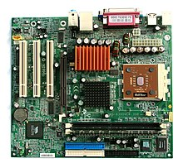A Motherboard shown in *Figure 1*, sometimes known as the Central Processor is one of the most important parts of a computer, the Motherboard brings all the other components together and allows them to communicate with each other.

Figure 1: Image taken from Wikipedia showing an example of a motherboard for a computer.

A printed circuit board, the Motherboard is often secured to the computer case and is made up of multiple sockets to support the connection of other peripherals like the RAM, CPU and GPU.

#### Chipset

One of the main components of the Mother Board is the Chipset. The Chipset allows communication between the CPU, Memory, storage, and other peripherals, supporting the efficient transfer of data.

In a blog post (Hameed, 2019) explains the pre 2000’s motherboard architecture with separate North and South Bridges, however an article by (Mounika, 2023) sites, post 2000’s manufacturers like Intel and AMD have favoured a move towards combining these into a single Chipset.

### 

### Processor (CPU)

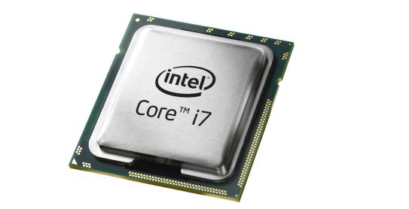The Central Processing Unit shown in *Figure 2*, is a primary component, acting like the brain or control centre, the CPU is responsible for running the computers Operating System and performs logic and arithmetic, as well as interpreting, processing, and executing instructions.

In his 2023 blog post (Walilko, 2023) explains CPU’s, cores and Threads, the more Threads a Core can process the better the speed and efficiency of multitasking*.*

Figure 2: Image taken from maelfabien.github.io this is an example of an Intel i7 processor chip.

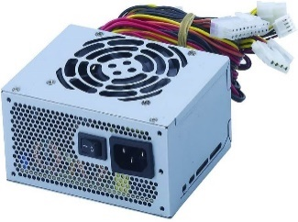

Figure 3: Image taken from minitool.com showing an example of a power supply for a computer.

### Power supply

A desktop PC like most other electronic devices uses Direct Current (DC), the job of the Power Supply shown in *Figure 3*, also known as the Power Supply Unit (PSU) is to convert alternating current (AC) into DC.

Another important feature of the PSU is its ability to provide a standby feature that provides a low 5v supply, a standby feature is important to allow certain peripherals to remain connected (Wikipedia.org, 2023).

Power is the fundamental part of any computing; further reading can be found in *Appendix - A We need to be smarter with energy consumption*.

### Memory (RAM)

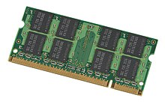Random-Access Memory (RAM), shown in *Figure 4*, is a computers *short term* memory, this is where data is stored when your computer is running its applications, and opening files.

Figure 4: Image taken from Wikipedia showing an example of a Random Access Memory for a computer.

RAM speed is critical to the user experience, each time a user makes a request in a game or when streaming a video, the RAM is used to load data into the CPU to share with the Applications (Intel, 2023).

Most Motherboards have multiple RAM slots which allow for a pair of RAM cards, also known as Multi Channel RAM. In an article by(Crucial.com, 2023)they explain Dual RAM is one type of multi-channel RAM, which can help to speed up the exchange of data with increased speeds. However, it’s important to understand that not all CPU’s can handle multi-channel RAM and consideration must be made for the CPUs memory controller.

### Permanent storage (HDD or SSD)

Although still used, the term *Permanent Storage* is widely considered redundant unless considering RAM, the term refers to offering the ability to store data regardless of an available power source. The term *non-volatile* has replace the term Permanent Storage and can be used when referring to HDD (Hard Dice Drives) or SSD (Solid State Drives), there is also Optical Storage in the form of Blue-Ray, DVD-R and DVD.

#### Hard Disc Drives

HDD’s are an older technology that allow storage of large amounts of data using an electromagnetic head to Read/Write data in Binary form with positive or negative charges.

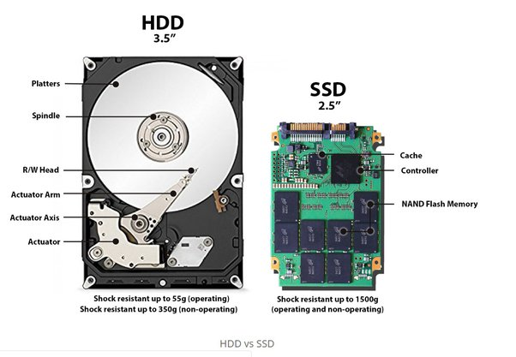The surface of the HDD is divided into circular tracks and sectors, splitting the surface of the HDD like this, provides physical addresses to remember where data is saved.

A PCB carefully co-ordinates a rotating disk and swinging access arm called the *Actuator* to allow the read/write head to access any location as quickly as possible.

#### Solid State Drives

SDD’s operate fast than traditional HDD’s, however the cost of SSD’s is still considerably higher than HDD’s for the same amount of storage space.

SSD’s use something called NAND flash memories, these are thousands of tiny transistors wired in a series. In their post *What is NAND?* (purestorage.com, 2023)explainNOT AND which refers to the Boolean Operators of the internal circuits, a NAND produces a False value if both inputs are TRUE.

Figure 5: Image taken from quora.com showing the key differences between HDD and SSD.

SSD’s have the advantage of having no mechanical moving parts and therefore immediate access to the data, however, over time they can be prone to something called *Leakage*. Leakage is where NAND cells can no longer retain their charge and start leaking electrons, this can lead to situations where Writes can be Read back immediately but overtime data retention can be affected.

(Computer Science GCSE Guru, 2023)

#### HDD v’s SSD – Risks & Benefits

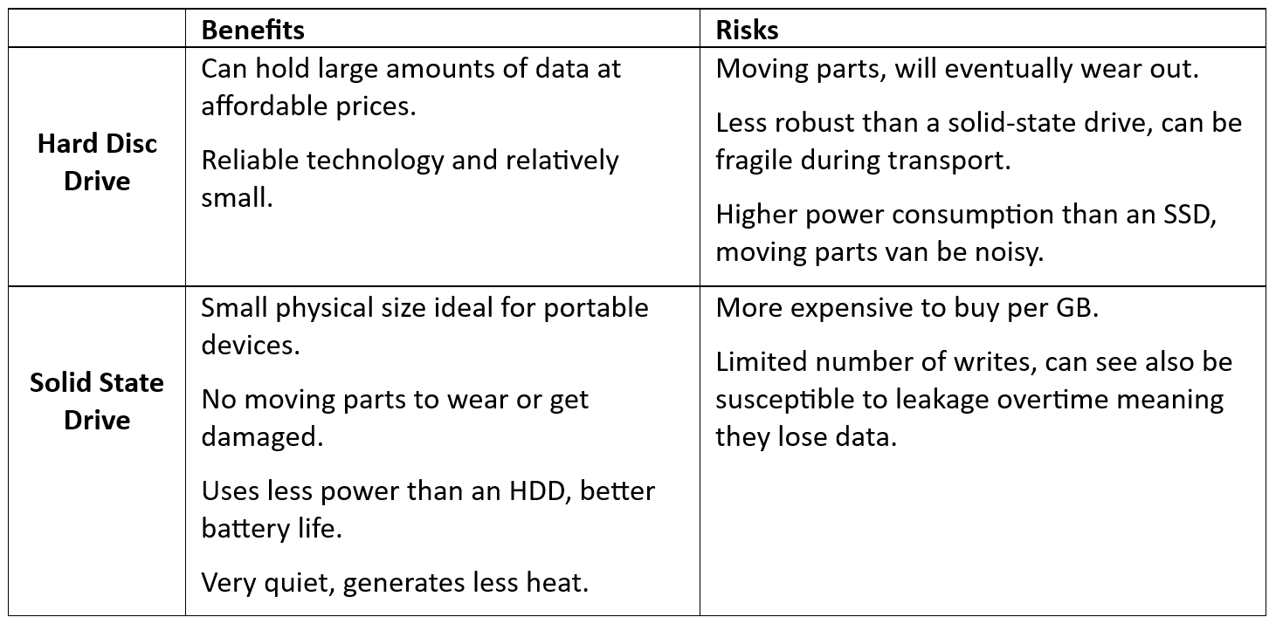

Figure 6: Table showing the benefits and risk of HDD and SSD

### 

### Network interface

A Network Interface Controller (NIC) shown in *Figure 7,* is a hardware component that supports a PC with connections to a Local Area Network (LAN).

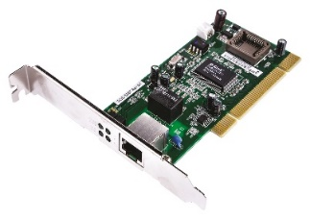The device itself is classified as Physical in the OSI model, however, the NIC works as part of Layer Two and is responsible for retaining the Media Access Control Address (MAC) and supports the transfer of the frames and data packets. You will also find references to the NIC at Layer 3 as it operates as an interface for the TCP and UDP protocols (Beevers, 2023).

Figure 7: Image from uk.rs-online.com showing an example of a NIC for a computer.

An article on (Network interface card, 2023) explains today’s NIC, there are many ways for devices to connect to our networks, you will find wireless connections, wired LAN connections, fibre optic and USB (Universal Serial Bus)*.*

### Graphics Interface

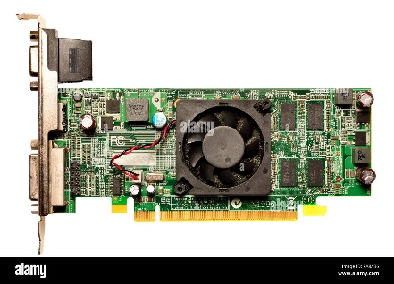Graphics Cards, also known as GPU (Graphic Processing Unit) shown in *Figure 8*, are a unit dedicated to processing the graphics that are required to run your computers applications.

Figure 8: Image from alamy.com showing an example of a GPU for a computer.

The image you see on your monitor is made of binary data, 0 and 1, the job of the GPU is to translate these into the rich pictures we use today. The computers applications work with the CPU to provide the GPU with data, the GPU then translates this into pixels to create the image on the screen (Tyson, et al., 2021).

Further reading can be found to support the section on GPUs in *Appendix B – More on Graphic Processing Unit*

## Exercise Two - Computer System Architecture

This section is a PowerPoint Presentation to explain how key computing functions are implemented in the hardware of two different devices, a Desktop Computer and Smartphone. Slide notes have been used and can be found on the lefthand side in *Fig 9 to 16*.

For a presentation view of this PowerPoint see *Appendix D - A PowerPoint Presentation to support Exercise Two*

### Slide One & Two – Presentation Cover

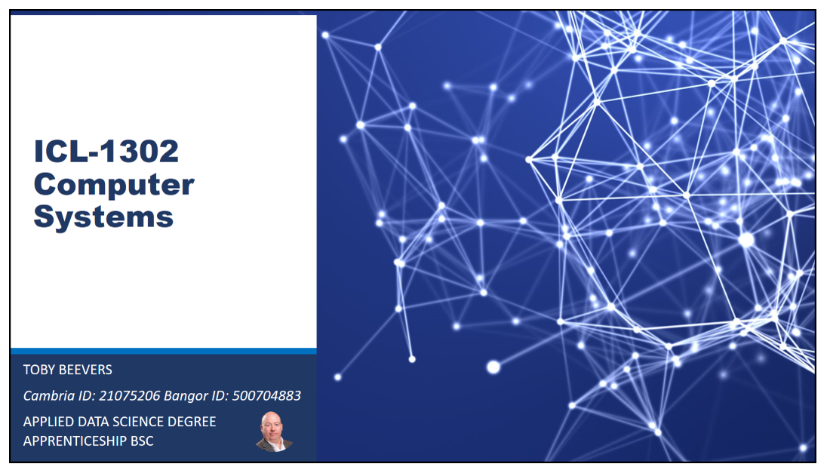

Figure 10: Slides One and Two from my PowerPoint presentation on Computer Systems Architecture

Figure 9: Slide Notes on Processors to accompany Slide Three, to be used as part of my presentation on System Architecture

### Slide Three - Processors

Figure 11: Slide Three from my PowerPoint presentation on Computer Systems Architecture

(Kimathi, 2022) (Tiny Green PC.com, 2017)

### Slide Four – Input/Output

Figure 12: Slide Notes on Input/Output to accompany Slide Four, to be used as part of my presentation on System Architecture

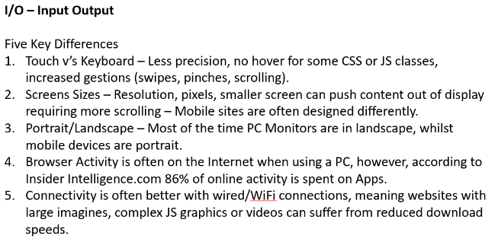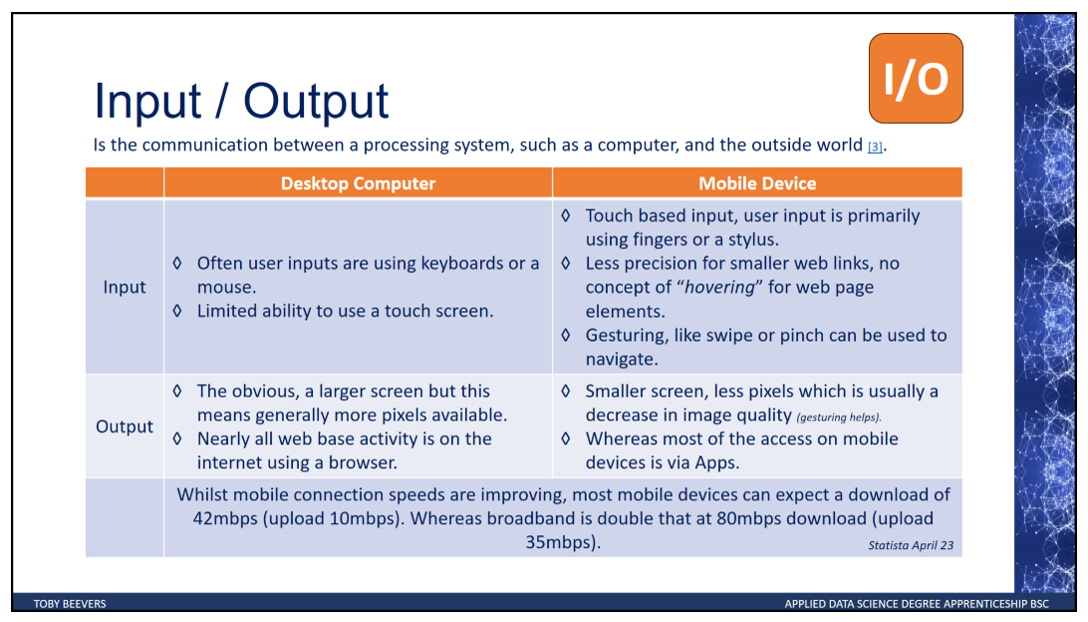

Figure 13: Slide Four from my PowerPoint presentation on Computer Systems Architecture

(Hart, 2017)

### Slide Five - Memory

Figure 14: Slide Notes on Memory to accompany Slide Five, to be used as part of my presentation on System Architecture

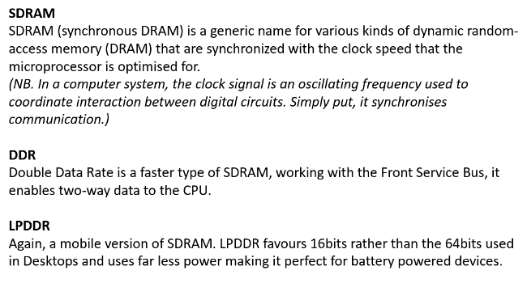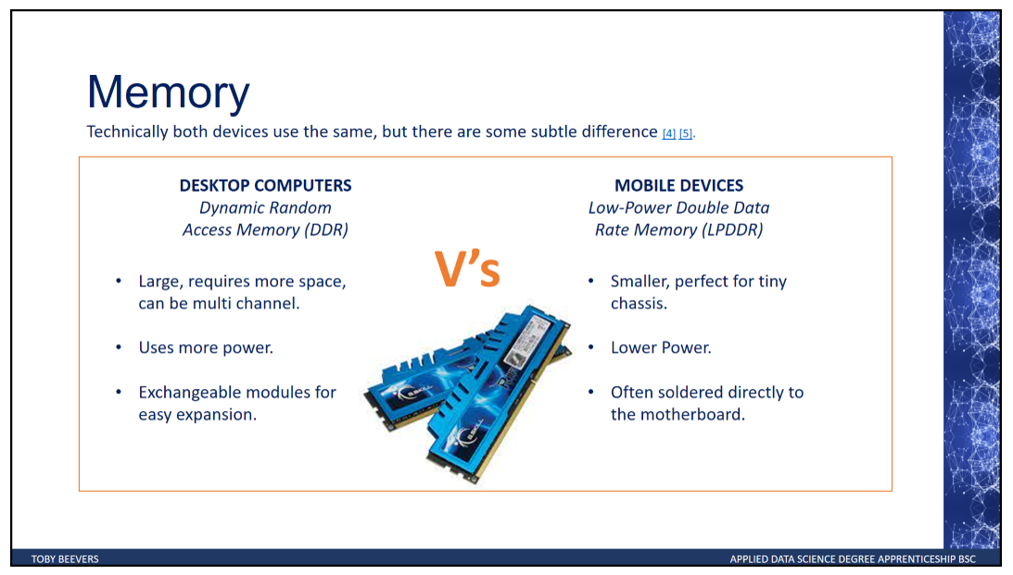

Figure 15: Slide Five from my PowerPoint presentation on Computer Systems Architecture

(Wikipedia.Org, 2023) (Wikipedia.Org, 2023)

### Slide Six - Storage

Figure 16: Slide Notes on Storage to accompany Slide Six, to be used as part of my presentation on System Architecture

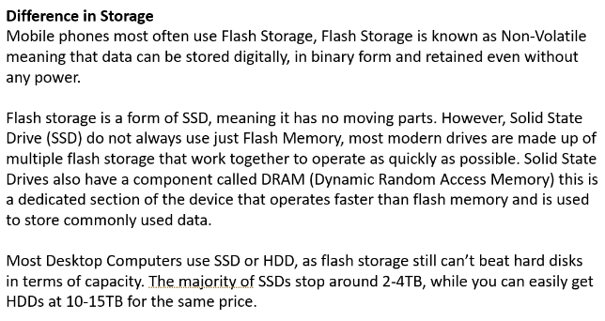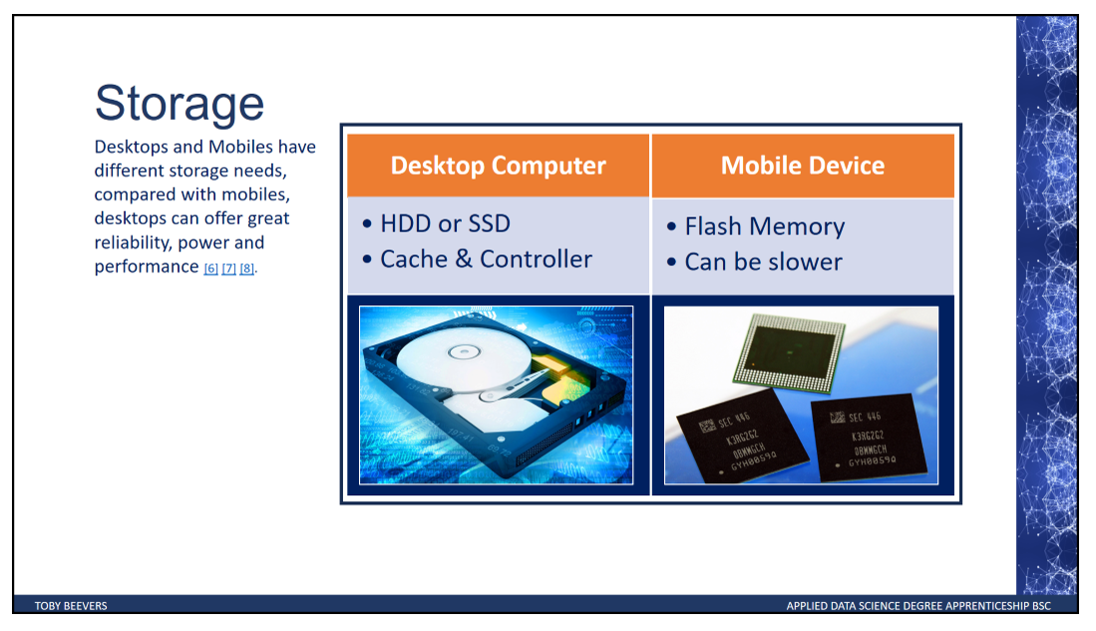

Figure 17: Slide Six from my PowerPoint presentation on Computer Systems Architecture

(Pure Storage, nd.) (Wikipedia.Org, 2023) (Wikipedia.Org, 2023)

### Slide Seven - Conclusion

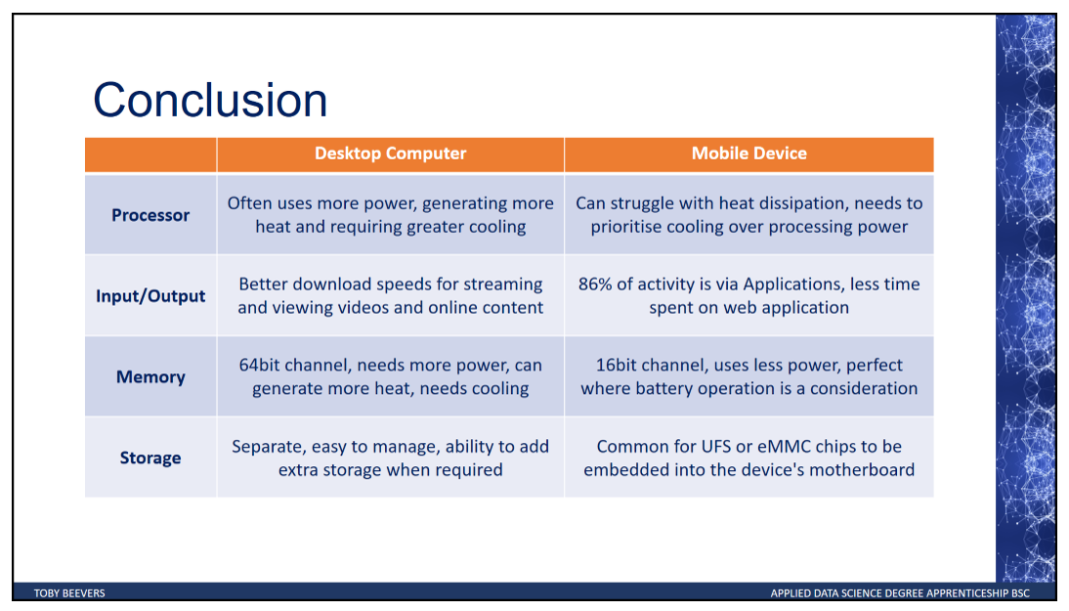

Figure 18: Slide Seven from my PowerPoint presentation on Computer Systems Architecture

## Exercise Three - Data Representation

The following images found in Fig, is a two-sided A4 handout aimed at students starting a course at Coleg Cambria to explain about data management.

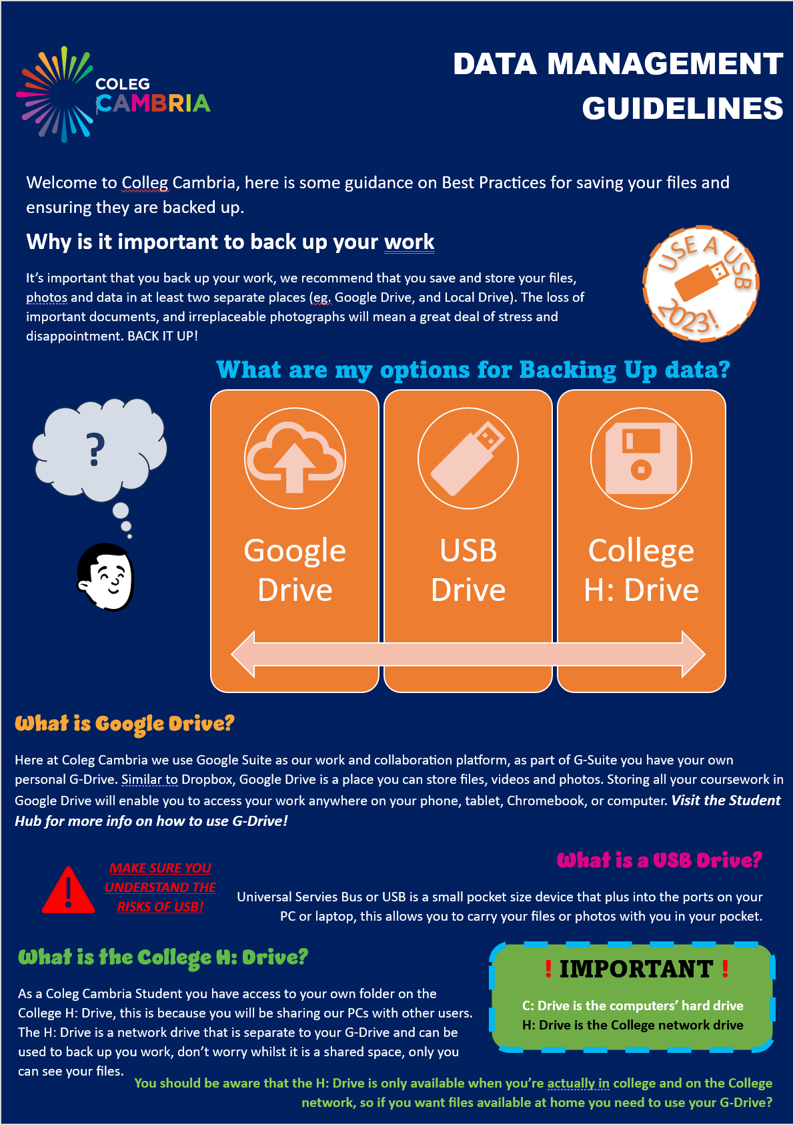

Figure 19: Side One of an A4 handout aimed at students join Coleg Cambria to explain data management best practices.

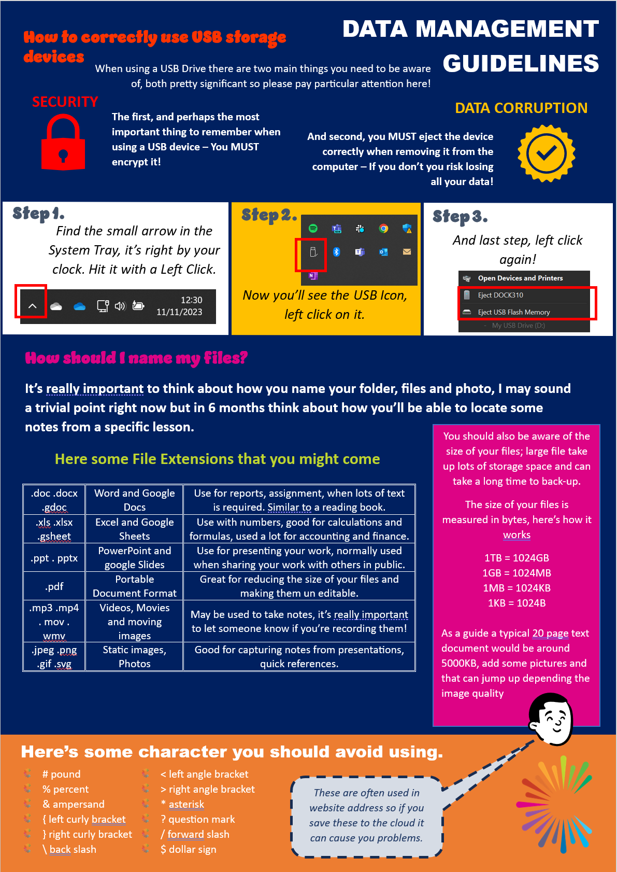

Figure 20: Side Two of an A4 handout aimed at students join Coleg Cambria to explain data management best practices.

## Exercise Four - Specify a computer to meet a requirement

### What is Battlefield One?

In October 2016 Electronic Arts (EA) publish Battlefield One, a single shooter game developed by DICE a subsidiary of EA.

The gameplay is based on a World War One period and is inspired by historical events. Although Battlefield is a single person shooter game, emphasis is given to teamwork which is supported by Multiplayer modes such as Rush, Operations and War Pigeon.

Reviews by critics where positive and the game was seen as an improvement on its predecessors Battlefield Four and Battlefield Hardline, selling over 15 million copies worldwide, and winning Best Action Game at the 2016 Game Critics’ Awards.

#### Requirements of Battlefield One

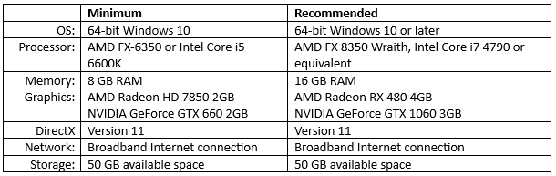

Figure 21: Table with a comparison of the minimum and recommended system requirements to run Battlefield One taken from the ea.com

### Battlefield One with Xbox One

The Xbox One and Xbox One S where release in 2013 and 2016, being one of the mainstream gaming consoles at the time of Battlefield One being released makes them a perfect candidate for a technical comparison. *Figure 22* below shows a comparison of the minimum system requirement to run Battlefield One and the system specification of the Xbox One S.

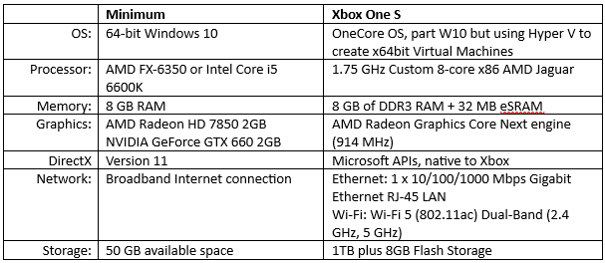

Figure 22: Table with a comparison of the minimum systems requirements to run the game Battlefield One and the key system specification of the Xbox One S

### Xbox One S Operating System

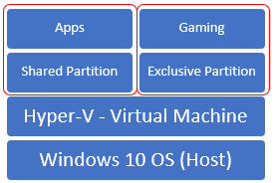The Xbox One S is producer by Microsoft and leverages parts of the Windows 10 OS which is in line with Microsoft’s *Windows Everywhere* approach.

The Xbox system uses a Hypervisor (Hyper-V) architecture as the host OS, with two partitions the first is a custom Virtual Machine used primarily for gaming, the second being used as a shared VM for running the OS and applications.

Figure 23: Visual representation showing Hyper-V architecture supporting partitions that share the same host Operating System.

(Microsoft, 2023)

#### Xbox One S Processor

AMDs Jaguar Chip is a low powered microarchitecture, referred to as an APU, the Jaguar chip combines a general-purpose CPU with a Graphics Processing unit in the same microcircuits.

The Xbox One S uses a custom version of the Jaguar chip which offers an increased power over the readily available AMD GPU, each custom Jaguar chip has two modules, each with eight cores (*standard is 4 cores*), however Threads are not shared across cores.

**CPU Comparison**



Figure 24: A table comparison of Central Processing Units by Intel and AMD and the Jaguar chip used in the Xbox One S

(Intel, 2023) (AMD, 2023)

#### Xbox One S Memory

The Xbox offers two slightly different Memory solutions 8GB DDRAM and 32GB SRAM, this design helps to try and reduce the latency of SRAM and increase capability benefits of DRAM.

As Xbox’s, by design are intended for gaming, the Memory availability is imperative for a successful user experience, each DRAM cell has transistors and capacitors in an integrated circuit, the data bit is stored in the capacitor. Transistors are known to leak a small amount, the capacitors will slowly discharge, causing information stored in it to drain, therefore DRAM must be refreshed every few milliseconds to retain their data.

SRAM is made up of four to six transistors, it keeps data in the memory if power is supplied to the system unlike DRAM, which must be refreshed periodically. This makes SRAM faster but also more expensive, meaning DRAM is often used more in computer systems.

#### Xbox One S Graphics

The GPU for the Xbox One S was a design by AMD based on the widely available Durango 2 chip, this is an integrated card that requires no extra power connector.

**GPU Comparison**

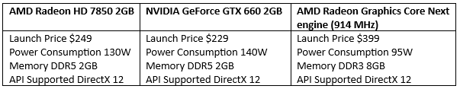

Figure 25: A table comparing Graphical Processing Units by NVIDIA and AMD.

### Battlefield One Desktop PC Comparison

The most important consideration for a gamer is User Experience, focusing on the Battlefield One UX and considering that most game play will be undertaken online, one can assume that network connection speed and frame rates are high on the agenda for any moderate gaming enthusiast.

Whilst this assignment calls for comparisons between hardware components, consideration for network speeds should not be underestimated, the user could spend £1,000’s on hardware and still not get the expected experience. Furthermore, the refresh rate of the users’ screen can also impact the FPS, investment into an expensive GPU could be restricted if the same level of consideration isn’t given to the monitor.

### Selecting CPU, Motherboard & Cooler

Selecting a CPU needs to be considered carefully, higher clock speeds and core counts can make a massive difference in performance, which provide smoother gameplay and faster completion of intensive tasks.

The CPU you choose will also dictate your motherboard options, as each processor only works with a specific CPU socket and chipset. Next you need to consider the case size of the machine, if you’re starting from scratch then you will be able to purchase the box that meets you needs, however, consideration needs to be given to head space and motherboard fixings.

Finally, the power supply, arguable the most importance component and often overlooked. Poor power supply selection can lead to voltage fluctuations and power surges that can damage parts of the PC. Similarly, your Power Supply might have enough power to keep your PC running when you’re not doing much, but once the GPU and the CPU begin to draw more power, it can struggle.

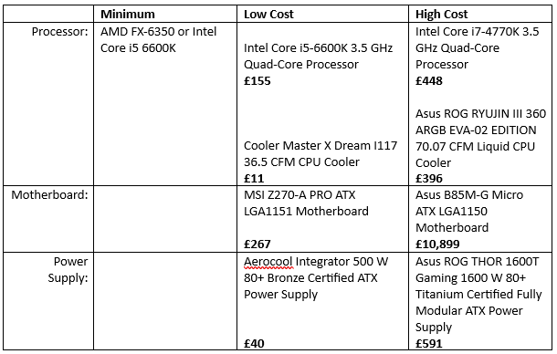

Figure 26: Table showing a low and high-cost comparison when considering processors, motherboards, and power supply to run Battlefield One on a personal computer.

### Memory & Storage

The original specification was using SRAM and DRAM due to the cost prohibition, however, advances in technology have allowed for a greater use of DRAM. Specs for Battlefield One ask for at least 8GB RAM but in today’s world I would be looking to increase this to a minimum of 16GB.

With the cost of storage greatly reducing since the launch of Battlefield the use of Solid-State Drives has become the norm, the important consideration is the Read/Write capacity of the SSD and whether the data is sequential or random.

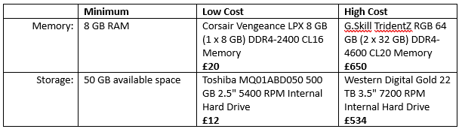

Figure 27: Table showing a low and high-cost comparison when considering memory and storage to run Battlefield One on a personal computer.

### Graphics & Sound

GPU or Graphics Card/Interface is perhaps seen as the most important part of any system for gaming purposes, however, just selecting a top end GPU does not guarantee the perfect user experience. Balance should be given to other hardware like monitors and a low refresh rate could mean you do not maximise your expense GPU at all.

The minimum GPU requirements for Battlefield 1 is 2GB, whilst it is possible to overclock you GPU, it is highly recommended so increase the headroom and your GPU to 4GB for a better user experience.

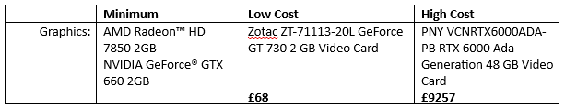

Figure 28: Table showing a low and high-cost comparison when considering graphics and sound to run Battlefield One on a personal computer.

## Exercise Five - Operating System Generic Functionality

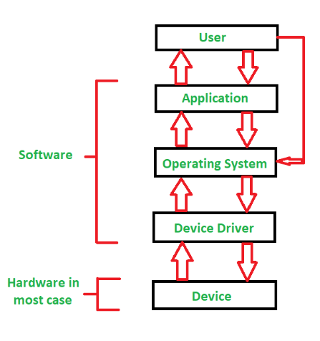In Exercise Two - Computer System Architecture we explained various hardware aspects of a desktop computer and a comparison with smart phones. Here, we delve deeper into essential computing functions and explain device drivers. While there isn't a single linear explanation for how a user's action relates to a specific hardware function, we aim to provide clarity on this intricate process.

*Figure 29* endeavours to depict the user's interaction with an application on the Operating System. However, it fails to address the Kernel, a topic we delve into more extensively later on.

### Applications

Applications are user-facing programs tailored for specific tasks like word processing, web browsing, or gaming. They directly interact with users to fulfil functions.

*Examples, Microsoft Word, Google Chrome, Photoshop.*

Figure 29: Illustration of the interaction between the user, OS, Device driver, and the devices, image taken from geeksforgeeks.org.

### Operating System

The OS is software that loads when the computer boots, the purpose of an OS is to control the hardware components. The Operating System employs various Managers like;

* The **device manager** which allocates resources to external hardware devices and allows them to be used by applications.
* The **memory manage**r which controls the allocation of memory between applications.
* The **file manage**r which controls the opening, reading, and writing of files in storage.
* And the **process manager** which controls the allocation of central processing unit (CPU) cycles to multiple running applications.

### Device Drivers

Device drivers are software facilitating communication between the OS and specific hardware devices. They enable the OS to recognise, control, and interact with hardware components.

*Example, NVIDIA graphics drivers, Realtek audio drivers.*

#### Input/Output

Input/Output devices primarily use the Device Manager to facilitates communication between peripherals and the CPU, managing input from devices such as keyboards, cameras, and output to devices like monitors, speakers.

#### Memory

Memory Manager is used to allocate and deallocate memory space, managing virtual memory, and ensuring efficient use of RAM.

#### Storage

File manager organises and manages data on storage devices, handling file access, and ensuring data integrity.

#### Processor

Processing primarily uses the Task Manager to allocate CPU resources to processes, managing task priority, and ensuring fair use of the CPU.

### The Kernal

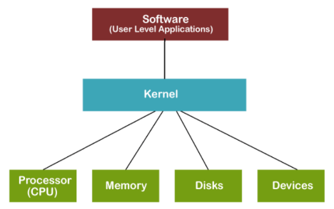

Figure 30: A basic diagram showing the Kernal layer and how it sits between the User Layer and the Hardware Layer.

*“In computer science, the Kernel is a computer program that is a core or heart of an operating system.”* (Javatpoint, 2024)

The Kernal can be considered a translation layer that fundamentally manages the Read/Write of the I/O as well as being the building block of the OS to manage the CPU, GPU, Memory and other key components.

In his YouTube channel (SavvyNik, 2022) explains the *Kernal* and how it forms a building block in Linux, as well as explaining how people often confuse the terms Linux and Linux Distribution in the same context. *SavvyNik* considers the *Kernal* as part of Linux which is use along with other programs to create Linux Distributions*.*

In the Microsoft Documentation, Kernel-Mode Driver Architecture Design Guide (Hudek, et al., 2024) give a detailed view of how the Microsoft Kernal works with various drivers and power management.

### Applications, Operating Systems & Device Drivers

In his 2022 blog, Jack Denver differentiates between Driver Software and Application Software, stating:

“*Application software is a type of software that helps users solve a particular problem or perform a specific task. Driver software is a type of software that accompanies a hardware component and helps it communicate with the rest of the computer system*” (Denver, 2022)*.*

This differentiation clarifies how users interact with Applications, which are part of the Operating System, working with Driver Software to communicate with hardware components. Managers within the OS, such as the device manager, memory manager, file manager, and process manager, work cohesively to allocate resources, control memory, manage files, and oversee CPU cycles, respectively.

## Exercise Six - Operating System Comparison

In Exercise Five - Operating System Generic Functionality we examined the distinct components of an operating system and their control over computer hardware. Concluding this portfolio, we delve into a comparison of these implementations in Windows OS and Mac OS X.

### The Kernel

#### The primary disparities between the Microsoft Windows and macOS kernels stem from their design philosophies and architectures.

#### Windows OS

Windows employs a monolithic kernel, where files, devices, and processes are all directly managed by the kernel itself. While this design offers speed and centralised processing, a disadvantage lies in its heavy reliance on each component; a single failure can lead to system-wide issues (Javatpoint.com, nd).

Figure 31: A visual representation of a monolithic Kernal System, taken from javatpoint.com

#### MacOS X

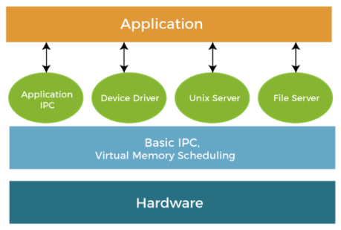macOS utilises a hybrid kernel architecture, blending elements of both monolithic and microkernel designs.

In a microkernel approach, the kernel handles only essential services, leaving the rest in the user layer. This architecture allows for easier modification of modules without significant impact on the kernel itself. (Javatpoint.com, nd).

Apple's XNU OS Kernel, developed in the 1990s, employs this hybrid approach, aiming to leverage the strengths of both monolithic and micro architectures to enhance security.

Figure 32: A visual representation of a micro kernel approach to the OS, taken from javatpoint.com

### Security

#### Operating system security models prioritise integrity, secrecy, and availability to safeguard users against threats like viruses, DoS attacks, and malware.

#### Windows OS

Historically, Windows has faced more security vulnerabilities, partly due to its widespread usage and popularity, making it a prime target for attacks.

#### macOS X

macOS boasts a stronger security reputation, attributed to Apple's stringent controls over its ecosystem. Additionally, its Unix-based heritage promotes granular permissions at the file level, aiding in managing unauthorised access.

### Drivers

Drivers serve as intermediaries facilitating interaction between hardware and the OS.

#### Windows OS

Windows has historically offered a wide array of drivers due to its support for various hardware configurations. However, the decentralised nature of driver distribution poses risks to system stability and security.

#### macOS X

In contrast, macOS maintains a more controlled driver ecosystem, with drivers primarily developed and distributed by Apple. Typically, there’s no need to add extra drivers with macOS as the system will often auto recognise popular devices, however, this can lead to some compatibility challenges with perennial devices.

### User Interface (UI)

Windows provides a highly customisable UI, offering users numerous personalisation options. Meanwhile, macOS prioritises simplicity and aesthetics in its UI design. A 2020 review in PC Mag (Muchmore, 2020), suggests a *Tie* between both OS for their customisation.

In summary, this comparison highlights the diverse approaches taken by Windows OS and macOS X in kernel architecture, security measures, driver ecosystems, and user interface design. Each operating system caters to distinct user preferences and requirements, contributing to their unique user experiences.

# Conclusion

In conclusion, this assignment has provided a comprehensive exploration of computer systems, spanning from their historical roots to contemporary and future innovations. Through exercises that dissected desktop PC hardware, computer system architecture, data representation, hardware specification for gaming, operating system functionality, and comparisons between Windows OS and macOS X, a holistic understanding of the intricate components and functionalities of computer systems has been achieved.

Beginning with a historical perspective, tracing the evolution from abacuses to the sophisticated computers of today, the assignment elucidated the transformative journey of computing technology. Noteworthy figures like Charles Babbage and Alan Turing were highlighted for their pioneering contributions, laying the foundation for the digital landscape we inhabit.

The exercise on desktop PC hardware delved into crucial components such as the motherboard, processor, memory, storage, network interface, and graphics interface, unravelling their significance in orchestrating the seamless functioning of computers. Detailed discussions on the architecture of these components provided insights into their roles and interactions within the system.

Furthermore, the assignment ventured into computer system architecture, elucidating the hardware implementations in desktop computers and smartphones through a PowerPoint presentation. This exercise elucidated the intricate interplay between hardware components in executing fundamental computing functions.

Data representation was explored, emphasising best practices for managing data effectively, crucial for aspiring students entering the realm of computer science. The specification of a computer to meet the requirements of a specific task, exemplified by Battlefield One, underscored the importance of aligning hardware specifications with software demands for optimal performance.

Moreover, the assignment delved into the generic functionality of operating systems, elucidating the roles of applications, device drivers, input/output management, memory allocation, storage management, and processor scheduling. Through meticulous analysis, it underscored the indispensable role of operating systems in mediating interactions between hardware and software components.

Lastly, a comparative analysis between Windows OS and macOS X provided insights into their respective kernel architectures, security models, driver ecosystems, and user interfaces. This exercise illuminated the contrasting approaches adopted by these operating systems, catering to diverse user preferences and requirements.

In essence, this assignment has fostered a deeper appreciation for the intricacies of computer systems, equipping the reader with a robust understanding of their components, functionalities, and evolutionary trajectories. As technology continues to advance at an unprecedented pace, the knowledge gleaned from this exploration will undoubtedly serve as a valuable compass for navigating the ever-changing landscape of computing.

# Appendix

## Appendix A - We need to be smarter with energy consumption

Figures from 2019 (Statista, 2019) suggest that 47.1% of households now own a personal computer. With the average computer uses about 746kw per year, the race is on to understand how designers can make PSUs more power efficient to help reduce the impact on carbon emissions.

In 2007 computer industry leaders combined forces with a common goal of promoting smart technologies that improve power efficiency and reduce energy consumption, they later combined with The Green Grid in 2012 (Wikipedia.Org, 2023)who goal is to create tools that optimise energy consumption.

*Mission Statement: The Green Grid works globally to create tools, provide technical expertise, and advocate for the optimization of energy and resource efficiency of Data Centre ecosystems which enables a low carbon economy* (The Green Grid, 2023).

## Appendix B – More on Graphic Processing Unit

#### GPU History

There is a rich history when it comes to Graphics Cards, consider how quickly user demands have changed over the last 15 years, how much gaming has changed for example.

Back in the 1970’s and early 80’s there where standard like VGA (Video Graphics Array), and MDA (IBMs Monochrome Display Adapter), the graphics requirement where so much less than we see today, just lines of green text rendered on to the screen.

As we moved into the 1990’s along came the gaming revolution, video graphics become common in arcades, we saw the introduction of the Saga Mega Drive. During this decade there was a massive acceleration and by the turn of the century we had multiple gaming consoles like the Play Station and the Nintendo 64.

Fast forward to 2023 and we can now join video calls on platforms like Microsoft Teams where we get to see people on the other side of the world, a long way from lines of green text. Hello World! (Wikipedia.Org, 2023).

#### GeForce RTX Founders Edition Graphics Cards: Cool and Quiet, and Factory Overclocked | GeForce News | NVIDIAToday’s World of GPUs

Figure 33: Image from nvidia.com showing a RTX2080 GPU

Today’s GPU market is one of the fastest growing segments in hardware, a 2022 market study suggested today’s value is somewhere in the region of $22,940M USD, and set to grow to $35,800M USD by 2028 (www.industryresearch.biz, 2023)*.*

## Appendix C – Student Practical Lab Session

During a session on Thursday 26th November 2023, the class established small groups with the target of dismantling and rebuilding a desktop computer. We had various difference levels within our group, some students had never seen inside a desktop computer, others had built their own desktop computer.

During the sessions, the more experienced members of the group oversaw the less experience members of the group and guided them through the processes of.

* Accessing the computer and removing the out case.
* Understanding where the RAM is located and how it attaches to the Motherboard.
* Locating the Central Processing Unit (CPU) on the Motherboard and removing the cooling systems to allow access to the CPU itself.
* Establishing the Storage Devices, in our case we had a Solid-State Drive (SSD).
* Detecting the Network Interface and seeing the connection to the Motherboard to understand how our PC connects to the Local Area Network (LAN).
* Pinpointing the Graphics Card (GPU), we had a discussion on the size of GPUs depending on the purpose of the machine.
* Understanding where the Power Supply is located, although we did not remove this.

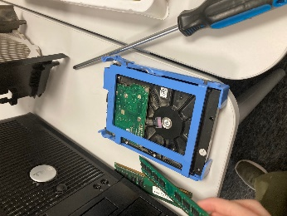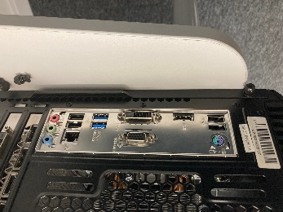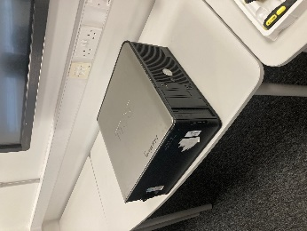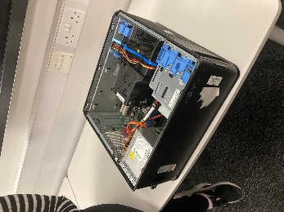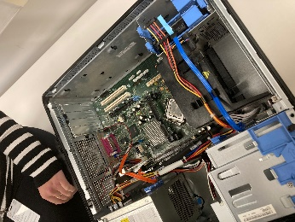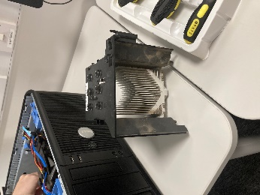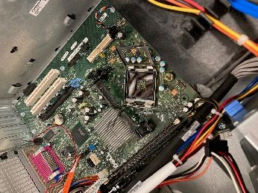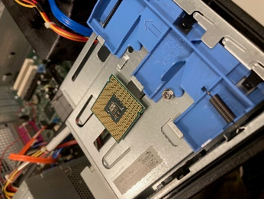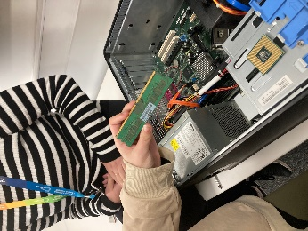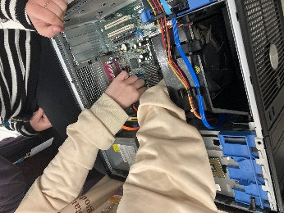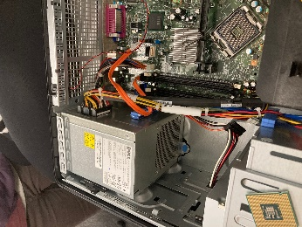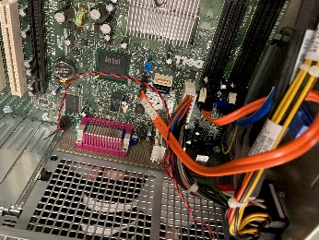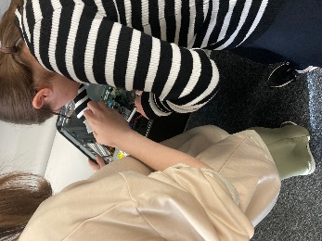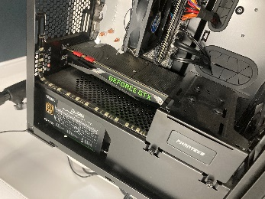

Then the Team rebuilt the Desktop and secured the case

## 

## Appendix D - A PowerPoint Presentation to support Exercise Two

*Double Click on the PowerPoint to open and run in Presentation Model*



# References

AMD, 2023. *FX-6350.* [Online]   
Available at: https://www.amd.com/en/product/1411  
[Accessed 10 12 2023].

Beevers, T., 2023. *ICL 1321 Web Technologies Exam.* Wrexham: Cambria.

Cambridge Advanced Learner's Dictionary & Thesaurus Cambridge University Press, 2023. *Motherboard.* [Online]   
Available at: https://dictionary.cambridge.org/dictionary/english/motherboard  
[Accessed 28 10 2023].

citypopulation.de/, 2021. *BROUGHTON.* [Online]   
Available at: https://citypopulation.de/en/uk/wales/flintshire/W45000108__broughton/  
[Accessed 25 11 2023].

Computer Science GCSE Guru, 2023. *Storage Devices.* [Online]   
Available at: https://www.computerscience.gcse.guru/theory/storage-devices  
[Accessed 02 11 2023].

Crucial.com, 2023. *What is Dual-Channel Memory?.* [Online]   
Available at: https://uk.crucial.com/articles/about-memory/what-is-dual-channel-memory#:~:text=Dual%2Dchannel%20RAM%20is%20one,memory%20and%20the%20memory%20controller.  
[Accessed 2 11 2023].

Denver, J., 2022. *Difference Between Driver Software & Application Software.* [Online]   
Available at: https://jackdenverblog.medium.com/difference-between-driver-software-application-software-3463fe321d8e#:~:text=Application%20software%20is%20a%20software,different%20hardware%20of%20the%20computer.  
[Accessed 03 02 2024].

Flinshire.gov, 2017. [Online]   
Available at: https://www.flintshire.gov.uk/en/PDFFiles/Policy-and-Performance/PSB/Well-being-assessment-Area-Profiles-English.pdf  
[Accessed 25 11 2023].

Guilizzoni, P., 2023. *What Are Wireframes?.* [Online]   
Available at: https://balsamiq.com/learn/articles/what-are-wireframes/  
[Accessed 25 11 2023].

Hameed, T., 2019. *North and south bridges of a motherboard explained.* [Online]   
Available at: https://srgtech78.wordpress.com/2019/01/25/north-and-south-bridges-of-a-motherboard-explained/  
[Accessed 28 10 2023].

Hart, S., 2017. *Mobile vs. Desktop: 10 Key Differences.* [Online]   
Available at: https://paradoxlabs.com/blog/mobile-vs-desktop-10-key-differences/   
[Accessed 01 11 2023].

Hudek, T., Graff, E. & Sherer, T., 2024. *Kernel-Mode Driver Architecture Design Guide.* [Online]   
Available at: https://learn.microsoft.com/en-us/windows-hardware/drivers/kernel/  
[Accessed 03 02 2024].

Intel, 2023. *Intel® Core™ i5-6600K Processor.* [Online]   
Available at: https://ark.intel.com/content/www/us/en/ark/products/88191/intel-core-i5-6600k-processor-6m-cache-up-to-3-90-ghz.html  
[Accessed 10 12 2023].

Intel, 2023. *What Is Computer and Laptop RAM?.* [Online]   
Available at: https://www.intel.com/content/www/us/en/tech-tips-and-tricks/computer-ram.html  
[Accessed 2 11 2023].

Javatpoint.com, nd. *Microkernel in Operating System.* [Online]   
Available at: https://www.javatpoint.com/microkernel-in-operating-system  
[Accessed 15 02 2024].

Javatpoint.com, nd. *Monolithic Structure of Operating System.* [Online]   
Available at: https://www.javatpoint.com/monolithic-structure-of-operating-system  
[Accessed 15 02 2024].

Javatpoint, 2024. *What is Kernel?.* [Online]   
Available at: https://www.javatpoint.com/what-is-kernel  
[Accessed 03 02 2024].

Kimathi, G., 2022. *The Difference Between Desktop and Mobile CPUs..* [Online]   
Available at: https://www.dignited.com/75924/desktop-and-mobile-cpus/   
[Accessed 03 11 2023].

Mckinsey & Company, 2022. *What is the Internet of Things?.* [Online]   
Available at: https://www.mckinsey.com/featured-insights/mckinsey-explainers/what-is-the-internet-of-things  
[Accessed 28 10 2023].

Microsoft, 2023. *Hyper-V Technology Overview.* [Online]   
Available at: https://learn.microsoft.com/en-us/windows-server/virtualization/hyper-v/hyper-v-technology-overview  
[Accessed 10 12 2023].

Mounika, D., 2023. *What is a Motherboard Chipset? How It Impacts the Performance?.* [Online]   
Available at: https://www.electronicshub.org/what-is-a-motherboard-chipset/  
[Accessed 28 10 2023].

Mounika, D., 2023. *What is a Motherboard Chipset? How It Impacts the Performance?.* [Online]   
Available at: https://www.electronicshub.org/what-is-a-motherboard-chipset/  
[Accessed 28 10 2023].

Muchmore, M., 2020. *macOS vs. Windows: Which OS Really Is the Best?.* [Online]   
Available at: https://uk.pcmag.com/software/118469/macos-vs-windows-which-os-really-is-the-best  
[Accessed 15 02 2024].

Network interface card, N., 2023. *Network interface card (NIC).* [Online]   
Available at: https://www.techtarget.com/searchnetworking/definition/network-interface-card  
[Accessed 5 11 2023].

Pure Storage, nd.. *What Is 3D NAND and How Does It Work?.* [Online]   
Available at: https://www.purestorage.com/knowledge/what-is-3d-nand.html#:~:text=What%20does%20NAND%20stand%20for,if%20both%20inputs%20are%20TRUE.   
[Accessed 02 11 2023].

purestorage.com, 2023. *What Is 3D NAND and How Does It Work?.* [Online]   
Available at: https://www.purestorage.com/knowledge/what-is-3d-nand.html#:~:text=What%20does%20NAND%20stand%20for,if%20both%20inputs%20are%20TRUE.  
[Accessed 2 11 2023].

SavvyNik, 2022. *What is a Kernel and what does it do? Explore the Kernels of Linux, Windows, and MacOS..* [Online]   
Available at: https://youtu.be/IvGdY6luTtU  
[Accessed 03 02 2024].

Statista, 2019. *Share of households with a computer at home worldwide from 2005 to 2019.* [Online]   
Available at: https://www.statista.com/statistics/748551/worldwide-households-with-computer/  
[Accessed 11 02 2024].

The Green Grid, 2023. *About Us.* [Online]   
Available at: https://www.thegreengrid.org/en/about-us  
[Accessed 28 10 2023].

Tiny Green PC.com, 2017. *What is the difference between Mobile CPU and Desktop CPU?.* [Online]   
Available at: https://www.tinygreenpc.com/blog/comparing-desktop-processor-and-mobile-processor/  
[Accessed 03 11 2023].

Tyson, j., Wilson, T. & Homer, T., 2021. *How Graphics Cards Work.* [Online]   
Available at: https://computer.howstuffworks.com/graphics-card.htm  
[Accessed 5 11 2023].

W3C Org, 2023. *Accessibility Fundamentals Overview.* [Online]   
Available at: https://www.w3.org/WAI/fundamentals/  
[Accessed 25 11 2023].

Walilko, A., 2023. *What Are CPU Cores vs Threads?.* [Online]   
Available at: https://www.liquidweb.com/blog/difference-cpu-cores-thread/#:~:text=A%20thread%20is%20a%20sequence,speed%20and%20efficiency%20of%20multitasking.  
[Accessed 28 10 2023].

Wikipedia.Org, 2023. *Climate Savers Computing Initiative.* [Online]   
Available at: https://en.wikipedia.org/wiki/Climate_Savers_Computing_Initiative  
[Accessed 28 10 2023].

Wikipedia.Org, 2023. *Computer.* [Online]   
Available at: https://en.wikipedia.org/wiki/Computer#History  
[Accessed 28 10 2023].

Wikipedia.Org, 2023. *DDR SDRAM.* [Online]   
Available at: https://en.wikipedia.org/wiki/DDR_SDRAM  
[Accessed 02 11 2023].

Wikipedia.Org, 2023. *Flash memory.* [Online]   
Available at: https://en.wikipedia.org/wiki/Flash_memory#NAND_flash   
[Accessed 02 11 2023].

Wikipedia.Org, 2023. *Graphics card.* [Online]   
Available at: https://en.wikipedia.org/wiki/Graphics_card  
[Accessed 5 11 2023].

Wikipedia.Org, 2023. *Mainframe computer.* [Online]   
Available at: https://en.wikipedia.org/wiki/Mainframe_computer  
[Accessed 28 10 2023].

Wikipedia.Org, 2023. *Motherboard.* [Online]   
Available at: https://en.wikipedia.org/wiki/Motherboard#Bootstrapping  
[Accessed 28 10 2023].

Wikipedia.org, 2023. *Power supply unit (computer).* [Online]   
Available at: https://en.wikipedia.org/wiki/Power_supply_unit_(computer)#Efficiency  
[Accessed 28 10 2023].

Wikipedia.Org, 2023. *Solid-state drive.* [Online]   
Available at: https://en.wikipedia.org/wiki/Solid-state_drive#:~:text=SSDs%20based%20on%20NAND%20flash,new%20drives%20it%20takes%20longer   
[Accessed 02 11 2023].

Wikipedia.Org, 2023. *Synchronous dynamic random-access memory.* [Online]   
Available at: https://en.wikipedia.org/wiki/Synchronous_dynamic_random-access_memory   
[Accessed 02 11 2023].

www.industryresearch.biz, 2023. *Graphics Processing Unit (GPU) Market Insights 2023: Technological Advancements, and Regional Growth Strategies 2030.* [Online]   
Available at: https://www.linkedin.com/pulse/graphics-processing-unit-gpu-market-insights-2023#:~:text=Market%20Analysis%20and%20Insights%3A%20Global,7.7%25%20during%20the%20review%20period  
[Accessed 5 11 2023].